**UI DESIGN DOCUMENT**

**CLAIMS MANAGEMENT SYSTEM**

Introduction:

This UI design document provides a comprehensive overview of the user interface requirements and design considerations for the *Claims Management System (CMS).* The CMS is designed to streamline the process of member registration, profile updates, claim requests, search claims, and claim processing. The document outlines the functional and non-functional requirements, user interface elements, visual design principles, and usability considerations that will guide the development of the CMS user interface.

About the Software System:

The client would like to develop an independent application, the Claims Management System (CMS). CMS is a system that helps members with member registration for claims, profile updates, claim requests, search claims and view status, and claim processing. The important *modules* in the system are:

* Dashboard
* New Member
* Update Member
* New Claim Request
* Search Claim
* Process Claim

**CMS – DASHBOARD**

*Description:*

The login page dashboard is the welcome page for the Claims Management System (CMS) application. It serves as the entry point for users and provides access to the various modules of the system. The dashboard displays relevant information and links to the different functionalities of the CMS.

*Requirements:*

1. The dashboard should be the first page displayed after successful login.

2. It should display a welcome message and provide links to the different modules of the CMS.

3. The dashboard should have a logout feature to allow users to securely log out of the system.

4. Access to the dashboard should be restricted to authenticated users only.

*Postcondition:*

Upon successful login, the dashboard is displayed with the relevant information and links to the CMS modules. Users can navigate to the different modules and perform their desired actions. When users log out, they are redirected to the login page.

*Business Rules:*

1. Only authenticated users can access the dashboard.

2. The dashboard should not display any sensitive information unless the user is authorized to view it.

3. User sessions should be managed securely to prevent unauthorized access to the dashboard.

4. The dashboard should be user-friendly and provide clear navigation to the different modules of the CMS.

**Visual Design**

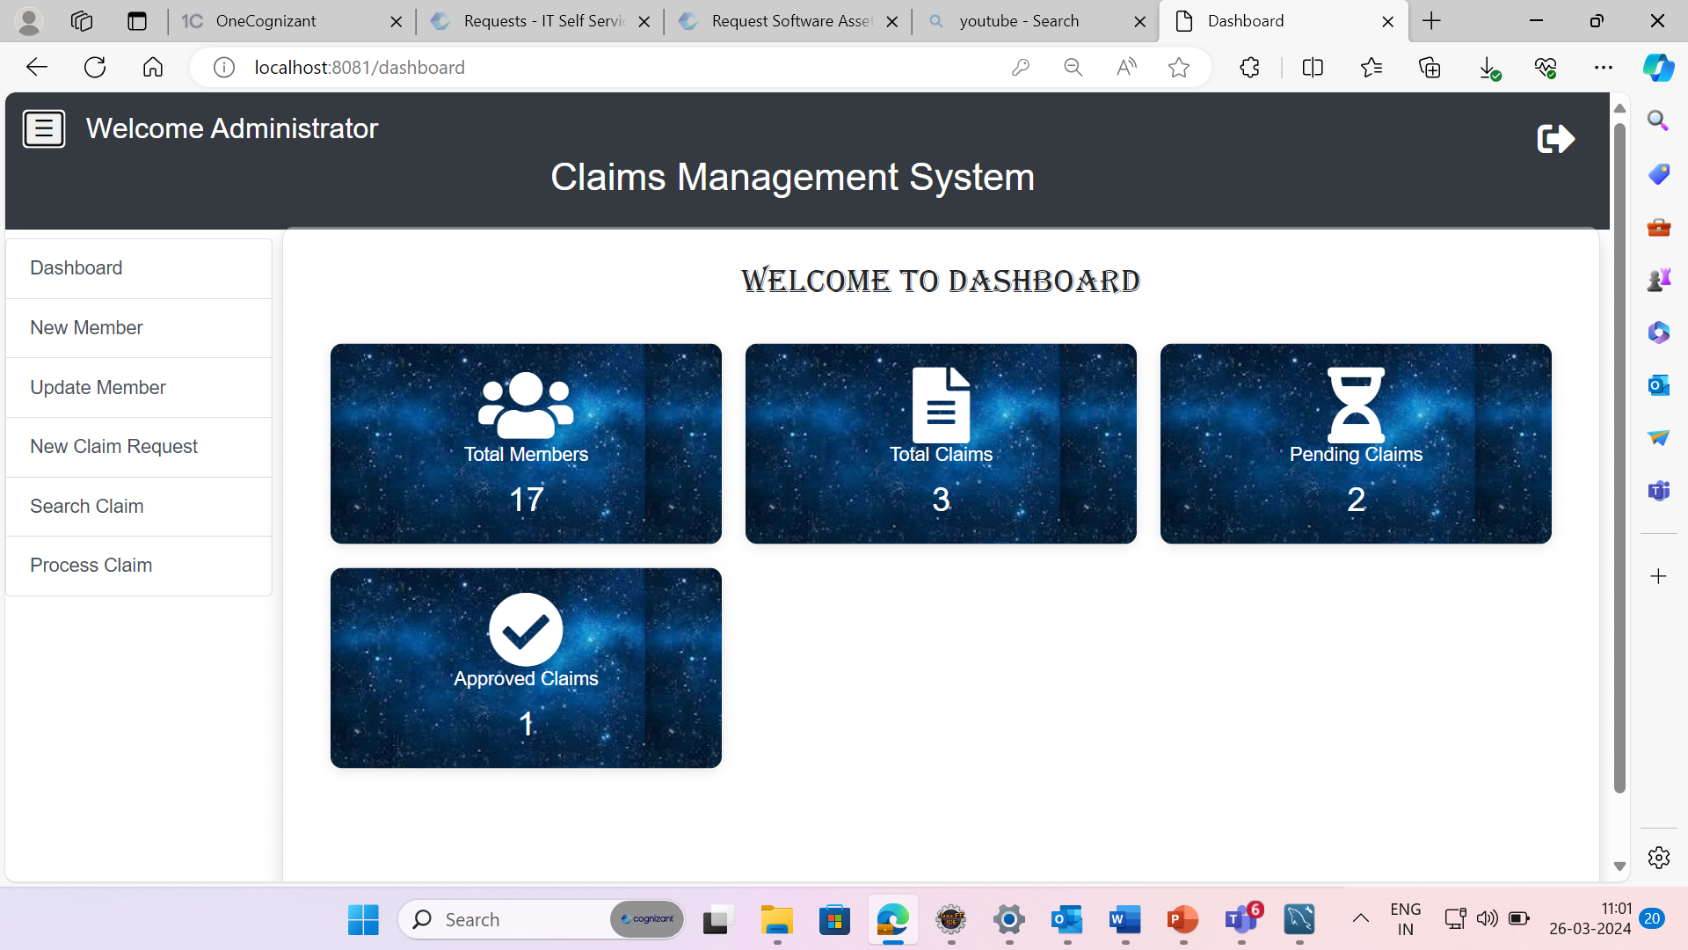

**CMS -NEW MEMBER**

*Description:*

Allows users to register as new members.

*Requirements:*

* User interface for member registration with fields for first name, last name, date of birth, address, contact number, email address, gender, nominee count, insurance type, insured amount, and maximum claimable amount.
* Validation rules for each field (e.g., mandatory fields, format of data).
* Generation of member ID in the format MBC-XXXXX, where X represents digits.

*Post Conditions:*

* System should generate the Member ID and update the database.
* Display success message upon successful registration.

*Business Rules:*

* All information is mandatory.
* Email ID should be unique.
* Nominees count should be between 1 to 3.

**Visual Design:**

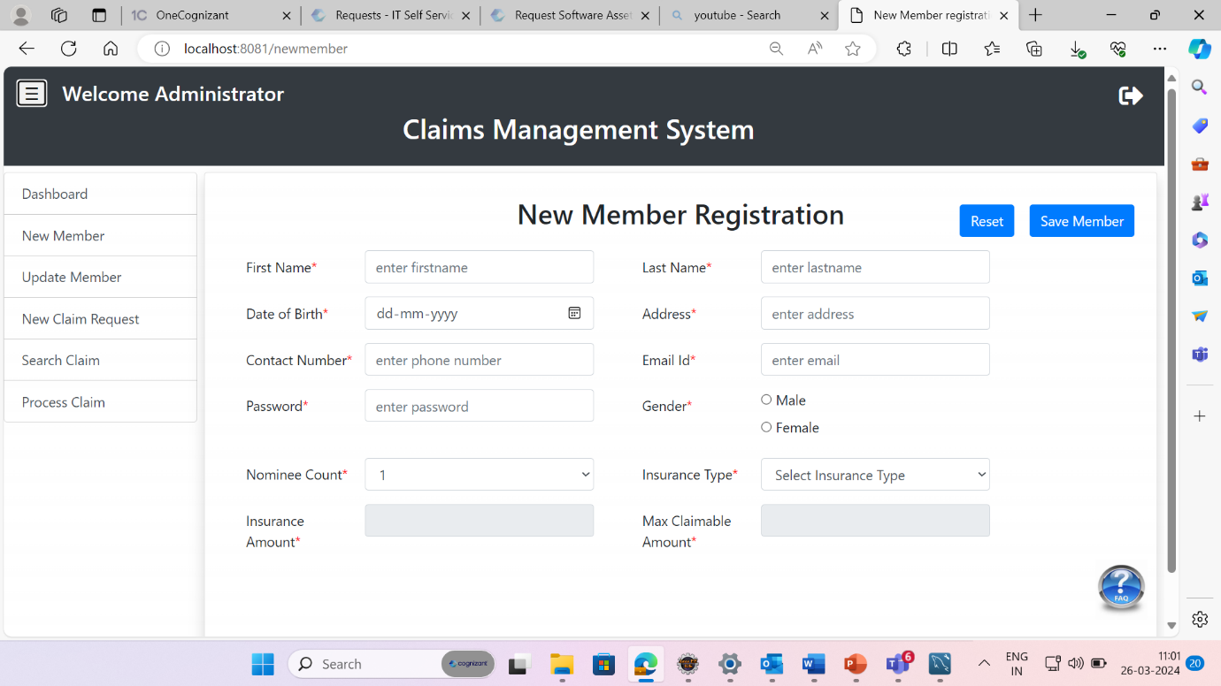

**CMS- UPDATE MEMBER**

*Description:*

* Allows members to update their profile information.

*Requirements:*

* User interface for member profile update with fields for first name, last name, date of birth, address, contact number, email address, gender, nominee count, insured amount, and maximum claimable amount.
* Pre-population of existing member details based on member ID.

*Post Conditions:*

* System should update the modified records to the database.
* Display success message upon successful update.

*Business Rules:*

* All information is mandatory.
* Email ID should be unique.
* Nominees can be added and deleted.

**Visual Design:**

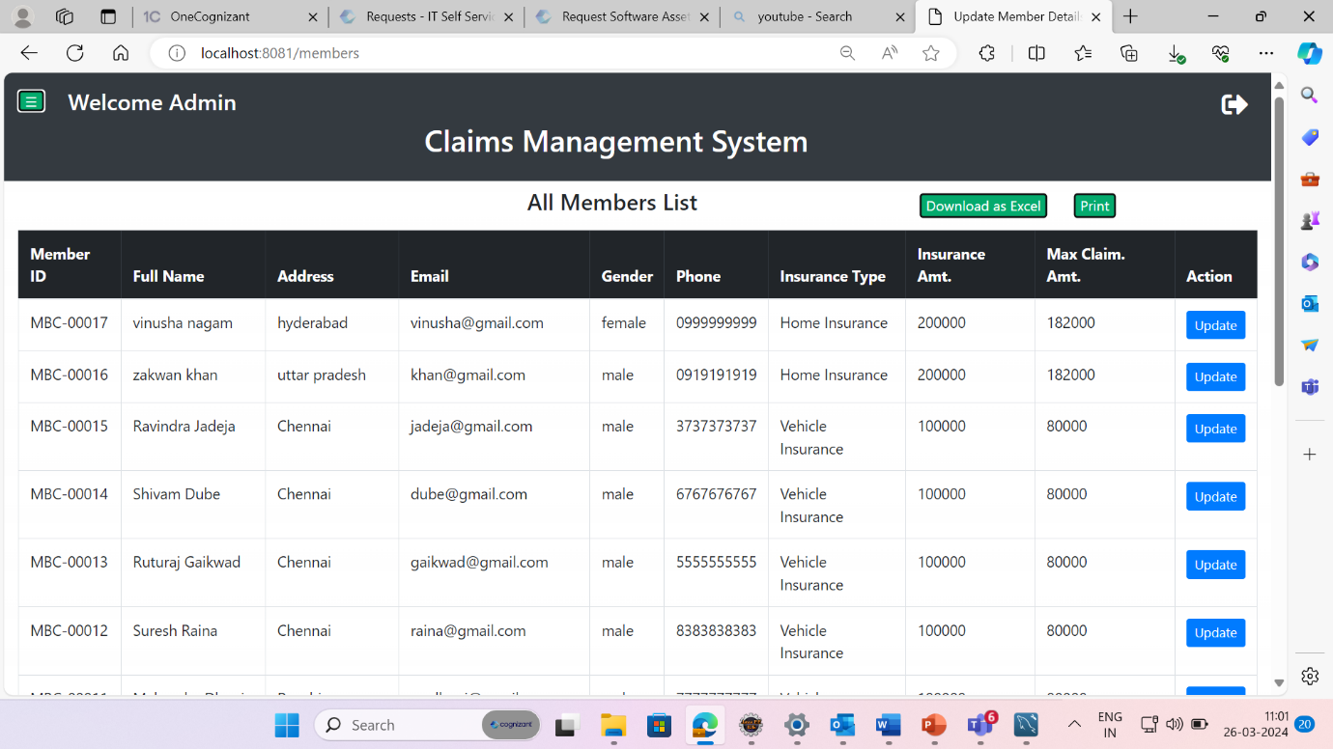

**CMS- NEW CLAIM REQUEST**

*Description:*

Allows members to request claims.

*Requirements:*

* User interface for member claim request with fields for member ID, first name, last name, nominee count, maximum claim amount, insurance type, request date, claim reason, and final claim amount.
* Calculation of final claim amount based on business rules.

*Post Conditions:*

* System should accept the claim details and update the database.
* Display success message with claim request number and processing date.

*Business Rules:*

* All information is mandatory.
* Claim request date should be the current date.
* Calculation of final claim amount based on insurance type and claim reason.

**Visual Design:**

**CMS- SEARCH CLAIM**

*Description:*

Allows users to search for claims and view status.

*Requirements:*

* User interface for searching claims with options to search by member ID, first name, request from date, and request to date.
* Validation rules for search conditions.

*Post Conditions:*

* Display search results in a table format.

*Business Rules:*

* Search options based on member ID, name, or dates.
* Request to date should not be greater than the current date.

**Visual Design:**

**CMS – PROCESS CLAIM**

*Description:*

Allows admins to process claims.

*Requirements:*

* User interface for claim processing with fields for member details, insurance type, insured amount, maximum claimable amount, request date, claim reason, final claim amount, and process claim (approval or rejection).
* Collection of documents for approval and rejection.

*Post Conditions:*

* Update claim status in the database.
* Display claim amount and availability date upon approval.

*Business Rules:*

* Validation of fields is mandatory.
* At least 3 documents must be collected for approval.
* Calculation of amount availability date by adding 10 days to the approval date.

**Visual Design:**

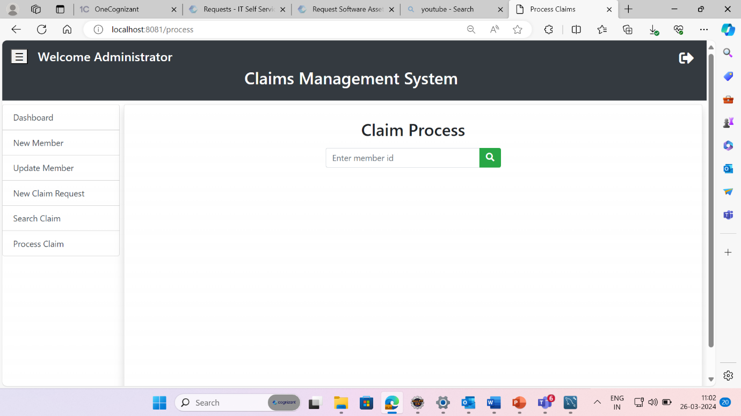

Nonfunctional Requirements:

***UI Requirements***

* User-friendly and pleasant front-end.
* User-readable error messages.
* Validated entered values.
* No debug messages on console.
* Errors and exceptions logged to a configurable log file.

***Performance Requirements***

* Front-end pages served in less than 5 seconds post-click for up to 1000 concurrent users.
* Safe and fast transactions.

***Installation, Deployment & Operational Requirements***

* Java/J2EE Framework application deployment.
* MySQL/SQL Server database for data storage.

***Maintainability & Portability Requirements***

* Increase allocated memory space without impacting performance.

***Security Requirements***

* No unauthorized access.
* User ID/Login ID combination of letters and numbers only.
* Validation of user ID/login ID and password.